
National College of Computer Studies Paknajol, Kathmandu

Lab Report of
Net Centric Computing

Submitted by: Submitted to:
Sajendra Bajracharya Yuba Raj Devkota
Roll No.:14

Questions

- Write a C# program to display "Hello, yourname!" using the .NET CLI. Compile and execute it to understand the compilation and execution process. Write compilation steps and replace yourname with your real name.
- Create a class with a constructor, properties (with get/set accessors), and a method to display object data. Instantiate the object and test it.
- Implement a base class Vehicle and a derived class Car. Use the base keyword to call the base class constructor and override a virtual method.
- Create an interface IShape with a method CalculateArea(). Implement it in two classes: Circle and Rectangle.
- Declare a delegate MathOperation that takes two integers and returns an integer. Assign it to methods for addition and multiplication and invoke them.
- Write a LINQ query using a lambda expression to filter and display even numbers from an integer array.
- Implement exception handling using try-catch-finally to handle division by zero and display a custom error message.
- Create a class Button with an event Clicked using a custom delegate ButtonClickHandler. Raise the event when a Click() method is called. Subscribe to the event in the main program and display a message when the button is clicked.
- Use LINQ to query a list of strings and retrieve all names that start with the letter 'A', are longer than 4 characters, and sort them in ascending order. Display the filtered results.
- Create an ASP.NET Core MVC application with a view that displays a simple calculator form with two textboxes (for numbers), a dropdown for operation (+, -, *, /), and a submit button. On submission, display the result below the form using a controller action and Razor view.
- Write a C# code snippet to connect to a SQL Server database using SqlConnection and execute a query to select all records from a table named Employees. (Use connection string and SqlCommand – just write the data access part inside a method.)
- Create an ASP.NET Core application that stores a user's name in Session and displays it on another page. Then, use TempData to pass a one-time notification (e.g., "Login successful") between two actions.
- Build a page that stores a user's theme preference (light/dark) in a cookie. Also, pass a product ID via query string to another page and display it.
- Create a registration form with client-side validation using jQuery. Validate fields (email, password strength) before submission and display error messages dynamically.
- Perform any lab by yourself so that every student will have different lab questions.

Write a C# program to display "Hello, your name!" using the .NET CLI. Compile and execute it to understand the compilation and execution process. Write compilation steps and replace your name with your real name.

using System;
class Program{
static void Main(string[] args){
Console.WriteLine("Hello, Sajendra!");
}
}

Output:
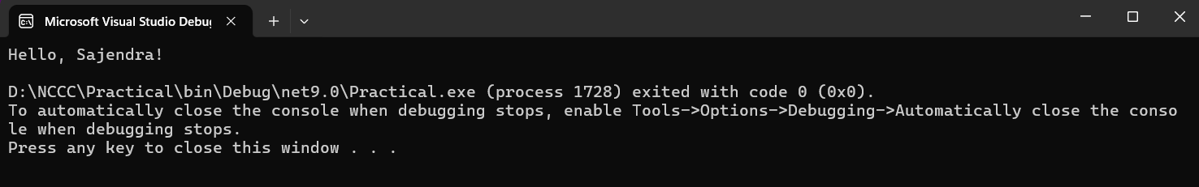

Create a class with a constructor, properties (with get/set accessors), and a method to display object data. Instantiate the object and test it.
using System;
class Student
{
private string name;
private string studentId;
private double gpa;

public Student(string name, string studentId, double gpa)
{
this.name = name;
this.studentId = studentId;
this.gpa = gpa;
}
public string Name
{
get { return name; }
set
{
if (!string.IsNullOrWhiteSpace(value))
name = value;
}
}
public string StudentId
{
get { return studentId; }
set
{
if (!string.IsNullOrWhiteSpace(value))
studentId = value;
}
}
public double GPA{
get { return gpa; }
set {
if (value >= 0.0 && value <= 4.0)
gpa = value;
}
}
public void DisplayInfo()
{
Console.WriteLine("\n========== Student Information ==========");
Console.WriteLine($"Name: {Name}");
Console.WriteLine($"Student ID: {StudentId}");
Console.WriteLine($"GPA: {GPA:F2}");
Console.WriteLine("=========================================\n");
}
public string GetGrade()
{
if (gpa >= 3.7) return "A";
else if (gpa >= 3.0) return "B";
else if (gpa >= 2.0) return "C";
else return "Below C";
}
}
class Program{
static void Main(string[] args) {
Console.WriteLine("=== C# Class Demonstration ===\n");
Student student1 = new Student("John Doe", "ST12345", 3.75);
student1.DisplayInfo();
Console.WriteLine($"Grade: {student1.GetGrade()}\n");
student1.Name = "John Smith";
student1.GPA = 3.90;
student1.DisplayInfo();
Student student2 = new Student("Alice Johnson", "ST67890", 3.95);
student2.DisplayInfo();
Console.WriteLine($"Grade: {student2.GetGrade()}");
Console.WriteLine("\n=== Program Completed ===");
}
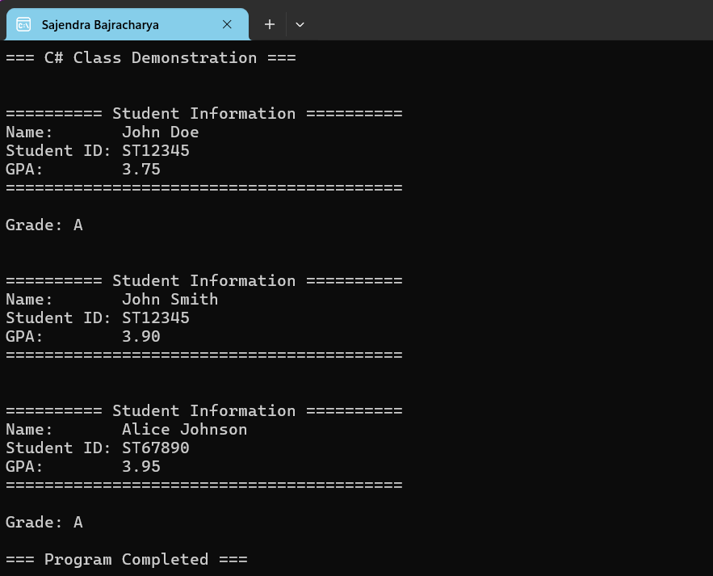
Output

Implement a base class Vehicle and a derived class Car. Use the base keyword to call the base class constructor and override a virtual method.

using System;
class Vehicle
{
protected string brand;
protected int speed;
public Vehicle(string brand, int speed)
{
this.brand = brand;
this.speed = speed;
}
public virtual void DisplayInfo()
{
Console.WriteLine("Vehicle Information");
Console.WriteLine($"Brand: {brand}");
Console.WriteLine($"Speed: {speed} km/h");
}
}
class Car : Vehicle
{
private int numberOfDoors;
public Car(string brand, int speed, int numberOfDoors)
: base(brand, speed)
{
this.numberOfDoors = numberOfDoors;
}
public override void DisplayInfo() {
Console.WriteLine("Car Information");
Console.WriteLine($"Brand: {brand}");
Console.WriteLine($"Speed: {speed} km/h");
Console.WriteLine($"Doors: {numberOfDoors}");
}
}
class Program{
static void Main(string[] args){
Vehicle car = new Car("Toyota", 180, 4);
car.DisplayInfo();
}
}
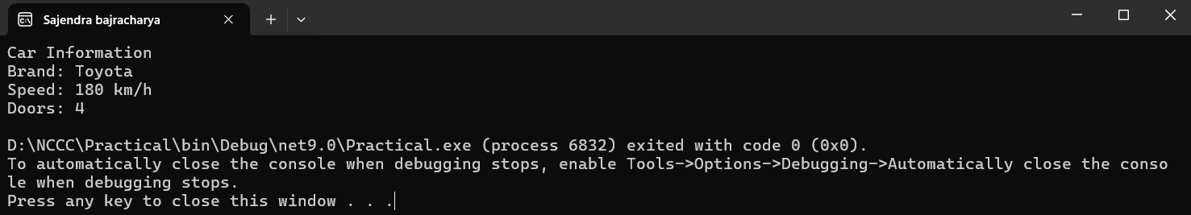
Output

Create an interface IShape with a method CalculateArea(). Implement it in two classes: Circle and Rectangle.
using System;
interface IShape{
double CalculateArea();
}
class Circle : IShape{
private double radius;
public Circle(double radius){
this.radius = radius;
public double CalculateArea(){
return Math.PI * radius * radius;
}
}
class Rectangle : IShape{
private double length;
private double width;
public Rectangle(double length, double width) {
this.length = length;
this.width = width;
}
public double CalculateArea()
{
return length * width;
}
}
class Program{
static void Main(string[] args){
IShape circle = new Circle(5);
IShape rectangle = new Rectangle(4, 6);
Console.WriteLine($"Circle Area: {circle.CalculateArea():F2}");
Console.WriteLine($"Rectangle Area: {rectangle.CalculateArea()}");
}
}

Output
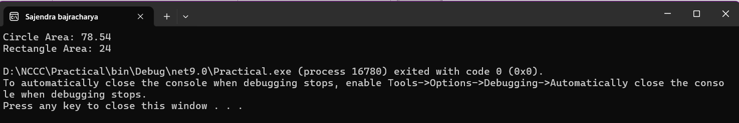

Declare a delegate MathOperation that takes two integers and returns an integer. Assign it to methods for addition and multiplication and invoke them.

using System;
delegate int MathOperation(int a, int b);
class Program {
static int Add(int x, int y)
{
return x + y;
}
static int Multiply(int x, int y){
return x * y;
}
static void Main(string[] args)
{
MathOperation operation;
operation = Add;
Console.WriteLine("Addition: " + operation(10, 5));
operation = Multiply;
Console.WriteLine("Multiplication: " + operation(10, 5));
}
}

Output
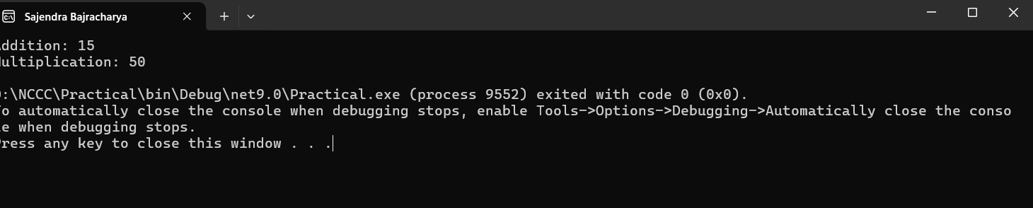

Write a LINQ query using a lambda expression to filter and display even numbers from an integer array.

using System;
using System.Linq;

class Linq
{
static void Main()
{
int[] numbers = { 1, 2, 3, 4, 5, 6, 7, 8, 9, 10 };

var evenNumbers = numbers.Where(n => n % 2 == 0);

Console.WriteLine("Even Numbers:");
foreach (var num in evenNumbers)
{
Console.WriteLine(num);
}
}
}

Output
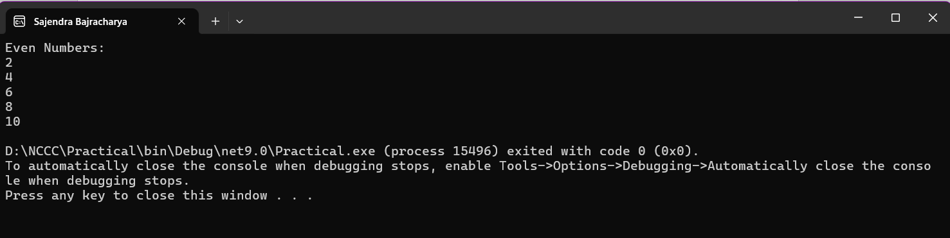

Implement exception handling using try-catch-finally to handle division by zero and display a custom error message.
using System;
class ExceptionHandler
{
static void Main()
{
try
{
Console.Write("Enter numerator: ");
int numerator = int.Parse(Console.ReadLine());

Console.Write("Enter denominator: ");
int denominator = int.Parse(Console.ReadLine());

int result = numerator / denominator;
Console.WriteLine("Result: " + result);
}
catch (DivideByZeroException)
{
Console.WriteLine("Error: Division by zero is not allowed.");
}
catch (FormatException)
{
Console.WriteLine("Error: Please enter valid integers.");
}
finally
{
Console.WriteLine("Program execution completed.");
}
}
}

output
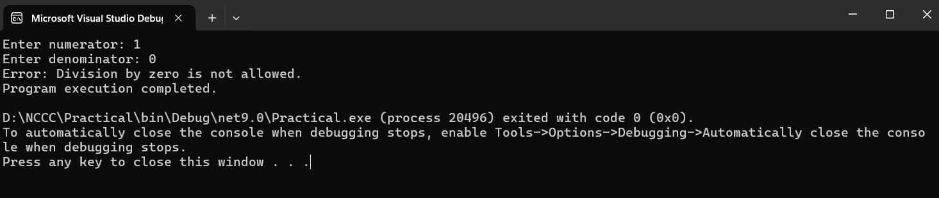

Create a class Button with an event Clicked using a custom delegate ButtonClickHandler. Raise the event when a Click() method is called. Subscribe to the event in the main program and display a message when the button is clicked.

using System;

delegate void ButtonClickHandler();

class Button
{
public event ButtonClickHandler Clicked;

public void Click()
{
Console.WriteLine("Button is clicked.");
Clicked?.Invoke();
}
}
class EventDemo
{
static void Main()
{
Button button = new Button();

button.Clicked += OnButtonClicked;

button.Click();
}

static void OnButtonClicked()
{
Console.WriteLine("Event handled: Button click event received.");
}
}

Output
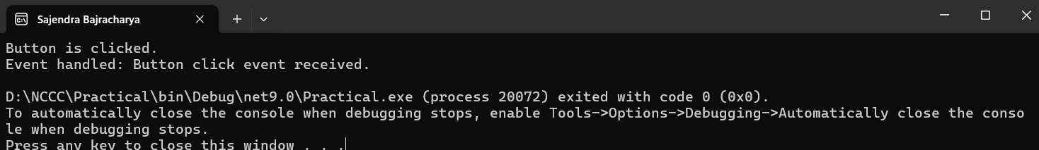

Use LINQ to query a list of strings and retrieve all names that start with the letter 'A', are longer than 4 characters, and sort them in ascending order. Display the filtered results.

using System;
using System.Collections.Generic;
using System.Linq;
class Program
{
static void Main()
{
List<string> names = new List<string>
{
"Anisha",
"Aleena",
"Bob",
"Amy",
"Anita",
"Suyog",
"Amanda"
};

var result = names.Where(name => name.StartsWith("A") && name.Length > 4).OrderBy(name => name);
Console.WriteLine("Filtered Names:");
foreach (var name in result)
{
Console.WriteLine(name);
}
}
}

Output
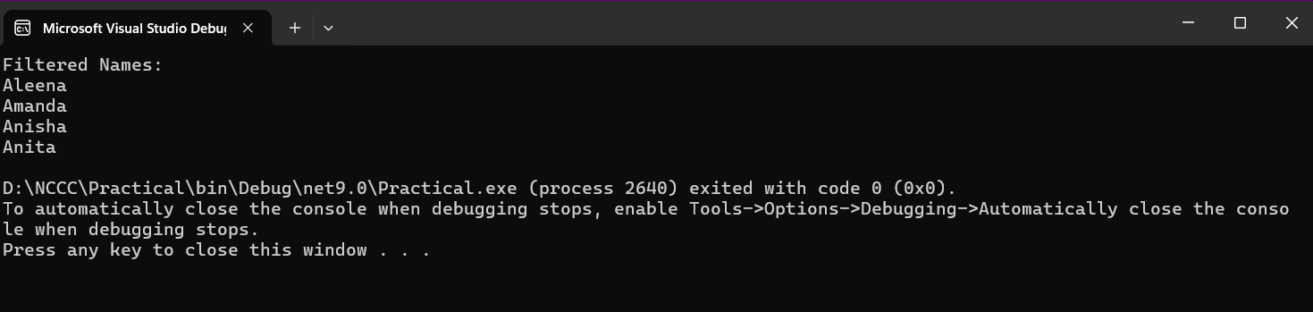

Create an ASP.NET Core MVC application with a view that displays a simple calculator form with two textboxes (for numbers), a dropdown for operation (+, -, *, /), and a submit button. On submission, display the result below the form using a controller action and Razor view.

Controller
using Calculator.Models;
using Calculator.Models;
using Microsoft.AspNetCore.Mvc;
using System.Diagnostics;
namespace CalculatorApp.Controllers
{
public class HomeController : Controller
{
private readonly ILogger<HomeController> _logger;
public HomeController(ILogger<HomeController> logger)
{
_logger = logger;
}
public IActionResult Index()
{
return View(new CalculatorModel());
}
[HttpPost]
[ValidateAntiForgeryToken]
public IActionResult Calculate(CalculatorModel model)
{
ModelState.Clear();
if (model.Operation != null && model.Operation != "")
{
try
{
switch (model.Operation)
{
case "+":
model.Result = model.Number1 + model.Number2;
break;
case "-":
model.Result = model.Number1 - model.Number2;
break;
case "*":
model.Result = model.Number1 * model.Number2;
break;
case "/":
if (model.Number2 == 0)
{
model.ErrorMessage = "Cannot divide by zero!";
}
else {
model.Result = model.Number1 / model.Number2;
}
break;
default:
model.ErrorMessage = "Invalid operation selected.";
break;
}
}
catch (Exception ex){
model.ErrorMessage = $"An error occurred: {ex.Message}";
}
}
else
{
model.ErrorMessage = "Please select an operation.";
}
return View("Index", model);
}
public IActionResult Privacy(){
return View();
}
[ResponseCache(Duration = 0, Location = ResponseCacheLocation.None, NoStore = true)]
public IActionResult Error(){
return View(new ErrorViewModel { RequestId = Activity.Current?.Id ?? HttpContext.TraceIdentifier });
}
}
}

Model
using System.ComponentModel.DataAnnotations;
namespace Calculator.Models{
public class CalculatorModel{
[Required(ErrorMessage = "First number is required")]
[Display(Name = "First Number")]
public double Number1 { get; set; }

[Required(ErrorMessage = "Second number is required")]
[Display(Name = "Second Number")]
public double Number2 { get; set; }
[Required(ErrorMessage = "Please select an operation")]
[Display(Name = "Operation")]
public string Operation { get; set; }
public double? Result { get; set; }
public string ErrorMessage { get; set; }
}
}

View
@model Calculator.Models.CalculatorModel
@{
ViewData["Title"] = "Home Page - Calculator";
}
<div class="text-center mb-4">
<h1 class="display-4">Welcome to the Calculator App</h1>
<p>Perform basic arithmetic operations below</p>
</div>
<div class="row justify-content-center">
<div class="col-md-6">
<div class="card shadow">
<div class="card-header bg-primary text-white">
<h2 class="mb-0">
<i class="bi bi-calculator"></i> Simple Calculator
</h2>
</div>
<div class="card-body">
<form asp-controller="Home" asp-action="Calculate" method="post">
<div class="mb-3">
<label asp-for="Number1" class="form-label"></label>
<input asp-for="Number1" class="form-control" type="number" step="any" placeholder="Enter first
<span asp-validation-for="Number1" class="text-danger"></span>
</div>
<div class="mb-3">
<label asp-for="Operation" class="form-label"></label>
<select asp-for="Operation" class="form-select">
<option value="">-- Select Operation --</option>
<option value="+">+ (Addition)</option>
<option value="-">- (Subtraction)</option>
<option value="*">* (Multiplication)</option>
<option value="/">&divide; (Division)</option>
</select>
<span asp-validation-for="Operation" class="text-danger"></span>
</div>
<div class="mb-3">
<label asp-for="Number2" class="form-label"></label>
<input asp-for="Number2" class="form-control" type="number" step="any" placeholder="Enter second number" />
<span asp-validation-for="Number2" class="text-danger"></span>
</div>
<div class="d-grid">
<button type="submit" class="btn btn-primary btn-lg">
<i class="bi bi-calculator-fill"></i> Calculate
</button>
</div>
</form>
@if (Model.Result. HasValue){
<div class="alert alert-success mt-4" role="alert">
<h4 class="alert-heading">
<i class="bi bi-check-circle"></i> Result
</h4>
<hr>
<p class="mb-0 fs-3">
<strong>@Model.Number1 @Model.Operation @Model.Number2 @Model.Result.Value</strong>
</p>
</div> }
@if (!string.IsNullOrEmpty(Model.ErrorMessage)){
<div class="alert alert-danger mt-4" role="alert">
<i class="bi bi-exclamation-triangle"></i>
<strong>Error:</strong> @Model.ErrorMessage
</div> }
</div>
</div>
</div>
</div>
@section Scripts {
<partial name="_ValidationScriptsPartial" />
}
Output
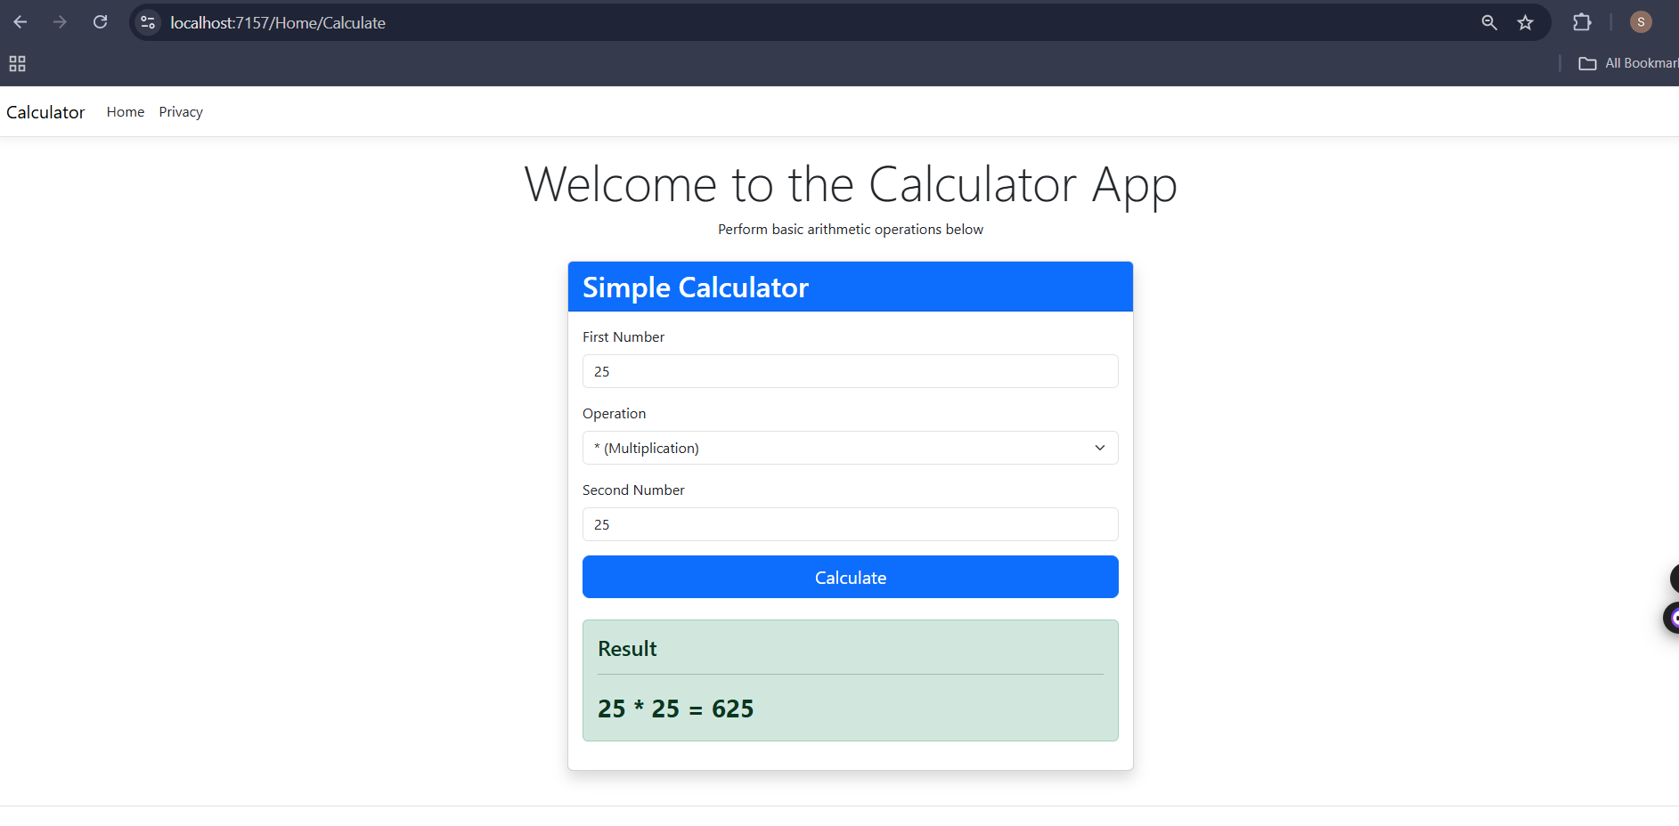

Write a C# code snippet to connect to a SQL Server database using SqlConnection and execute a query to select all records from a table named Employees. (Use connection string and SqlCommand – just write the data access part inside a method.)
using System;
using Microsoft.Data.SqlClient;
class Program
{
static void Main()
{
string connectionString = @"Server=SAJENDRA;Database=CompanyDB;Integrated Security=true;TrustServerCertificate=true;";

GetAllEmployees(connectionString);

Console.WriteLine("\nPress any key to exit...");
Console.ReadKey();
}

static void GetAllEmployees(string connectionString)
{
string query = "SELECT * FROM Employees";

using (SqlConnection connection = new SqlConnection(connectionString))
{
try
{
connection.Open();
Console.WriteLine("Connected to database successfully!\n");

SqlCommand command = new SqlCommand(query, connection);
SqlDataReader reader = command.ExecuteReader();

Console.WriteLine("EMPLOYEE RECORDS:");
Console.WriteLine("=".PadRight(80, '='));

while (reader.Read())
{
Console.WriteLine($"ID: {reader["EmployeeId"]}");
Console.WriteLine($"Name: {reader["FirstName"]} {reader["LastName"]}");
Console.WriteLine($"Department: {reader["Department"]}");
Console.WriteLine($"Salary: ${reader["Salary"]:N2}");
Console.WriteLine($"Hire Date: {reader["HireDate"]:yyyy-MM-dd}");
Console.WriteLine("-".PadRight(80, '-'));
}
reader.Close();
}
catch (SqlException ex)
{
Console.WriteLine($"Database Error: {ex.Message}");
}
catch (Exception ex)
{
Console.WriteLine($"Error: {ex.Message}");
}
}
}
}

Output
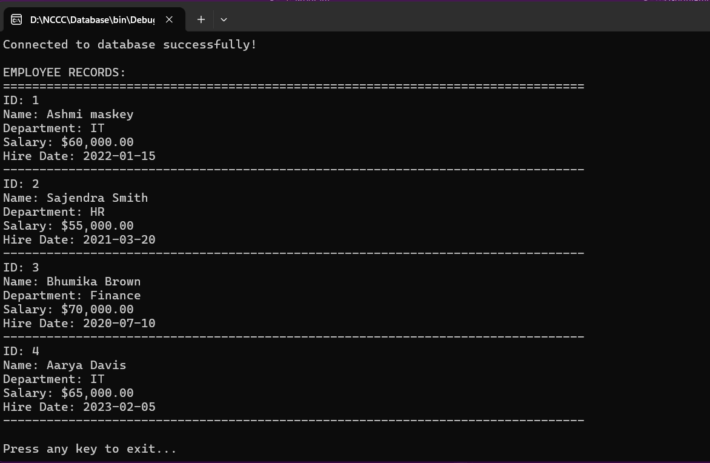

Create an ASP.NET Core application that stores a user's name in Session and displays it on another page. Then, use TempData to pass a one-time notification (e.g., "Login successful") between two actions.
Controller
using Microsoft.AspNetCore.Mvc;
namespace Session_and_cookie.Controllers
{
public class HomeController : Controller
{
public IActionResult Index()
{
return View();
}
[HttpPost]
public IActionResult SaveName(string username)
{
HttpContext.Session.SetString("UserName", username);
TempData["Message"] = "Login successful";

return RedirectToAction("Welcome");
}
public IActionResult Welcome()
{
ViewBag.Name = HttpContext.Session.GetString("UserName");
return View();
}
}
}
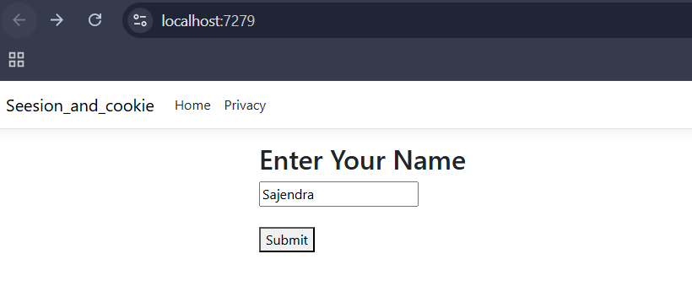
View
@{
ViewData["Title"] = "Login";
}

<h2>Enter Your Name</h2>

<form method="post" asp-action="SaveName">
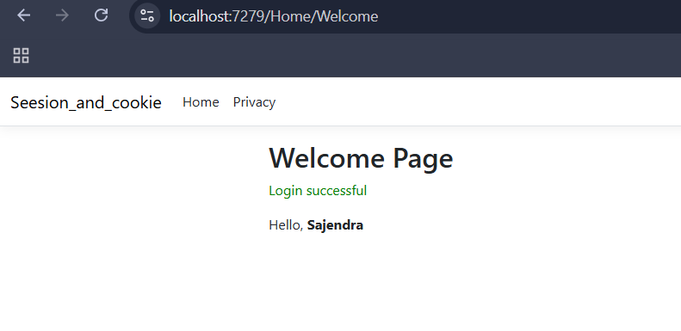
<input type="text" name="username" required />
<br /><br />
<button type="submit">Submit</button>
</form>

Build a page that stores a user's theme preference (light/dark) in a cookie. Also, pass a product ID via query string to another page and display it.
Controller
using Microsoft.AspNetCore.Mvc;

namespace CookieQueryDemo.Controllers
{
public class HomeController : Controller
{
public IActionResult Index()
{
// Read cookie if exists
ViewBag.Theme = Request.Cookies["Theme"];
return View();
}
[HttpPost]
public IActionResult SetTheme(string theme)
{
CookieOptions options = new CookieOptions
{
Expires = DateTime.Now.AddDays(7)
};

Response.Cookies.Append("Theme", theme, options);

return RedirectToAction("Index");
}

// Page 2 (Query String)
public IActionResult Product(int id)
{
ViewBag.ProductId = id;
return View();
}
}
}

View
@{
ViewData["Title"] = "Theme Selection";
var theme = ViewBag.Theme;
}

<style>
body.light {
background-color: #ffffff;
color: #000000;
}

body.dark {
background-color: #121212;
color: #ffffff;
}
</style>

<script>
document.addEventListener("DOMContentLoaded", function () {
document.body.className = "@theme".toLowerCase();
});
</script>

<h2>Select Theme</h2>

<form method="post" asp-action="SetTheme">
<label>
<input type="radio" name="theme" value="Light" @(theme == "Light" ? "checked" : "") />
Light
</label><br />

<label>
<input type="radio" name="theme" value="Dark" @(theme == "Dark" ? "checked" : "") />
Dark
</label><br /><br />

<button type="submit">Save Theme</button>
</form>

<hr />

<a href="/Home/Product?id=101">Go to Product Page</a>

Output
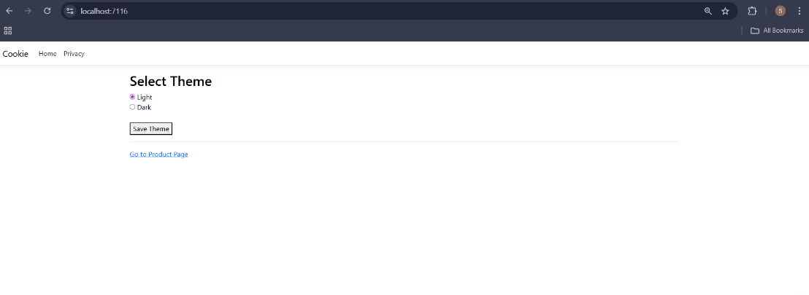
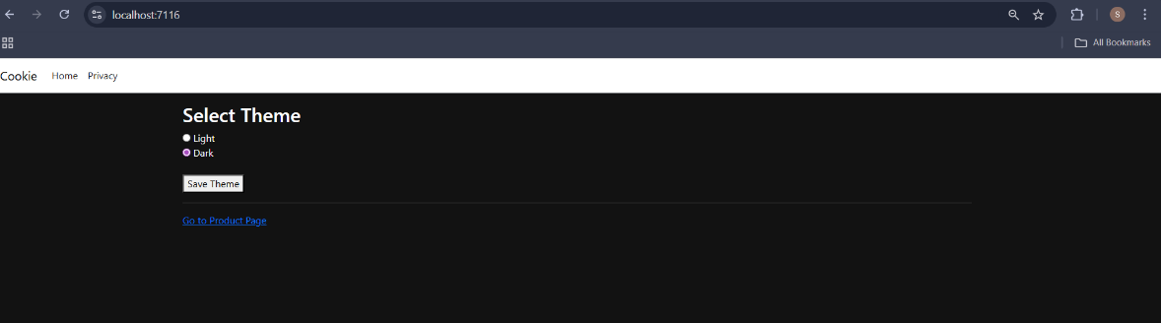

Create a registration form with client-side validation using jQuery. Validate fields (email, password strength) before submission and display error messages dynamically.
@model Client_validation.Models.UserRegistration
@{
ViewData["Title"] = "Home";
}
<!DOCTYPE html>
<html lang="en">
<head>
<meta charset="utf-8" />
<meta name="viewport" content="width=device-width" />
<title>Registration</title>
<script src="https://code.jquery.com/jquery-3.6.0.min.js"></script>
<style>
.error {
color: red;
font-size: 12px;
}
.success {
color: green;
font-size: 14px;
}
input {
margin-bottom: 10px;
display: block;
}
</style>
</head>
<body>
<div>
<h2>Registration Form</h2>
@if (ViewBag.Message != null)
{
<div class="success">@ViewBag.Message</div>
}
<form id="registrationForm" asp-action="Register" method="post">
<input type="text"
id="Email"
name="Email"
placeholder="Email"
value="@(Model?.Email ?? string.Empty)" />
<span id="emailError" class="error"></span>
<input type="password"
id="Password"
name="Password"
placeholder="Password" />
<span id="passwordError" class="error"></span>
<button type="submit">Register</button>
</form>
</div>
</body>
</html>

Output:
